Servlet assignment

1. Write Servlet application to print current date & time?

Ref : use simple Date object

1. Write a servlet application to establish communication between html and servlet page using hyperlink.

Ref : <a href = "http://localhost:8080/ServletApp/anchortag">check</a>

1. Write a servlet that refreshes the browser every second and current time will be changed automatically.

Ref : GregorianCalendar , response header

1. Write a Servlet application to count the total number of visits on the website.
2. Write a Servlet program that accepts the age and name and displays if the user is eligible for voting or not.
3. Write an application to demonstrate the session tracking in Servlet with following details

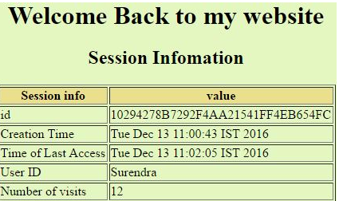

1. Write a Servlet application for login page, which is check the username and password. If username and password are matched, display welcome message along with username

Ref : login.html and LoginServlet . username and password can be hard coded or retrieved from database through service and dao layer?

1. Develop a registration page in servlet with proper validation and store all records in the database.

Ref

* create table registration (registerid int primary key , first_name varchar(20), email varchar(20), mobile number, dob DATE ,gender varchar(6), country varchar (10));
* INSERT INTO registration (first_name,email, mobile ,dob,gender,country) VALUES('John','john@hcl.com',’9988776655, '2019-03-01',’male’,’India’);
* a) register.html b) RegisterServlet.java c) web.xml d) RegisterService (interface) e)RegisterServiceImpl f) RegisterDao (interface) g)RegisterDaoImpl h)display.jsp

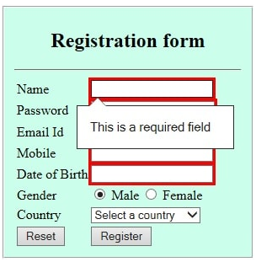

1. Develop an application on Java Servlet E-shop

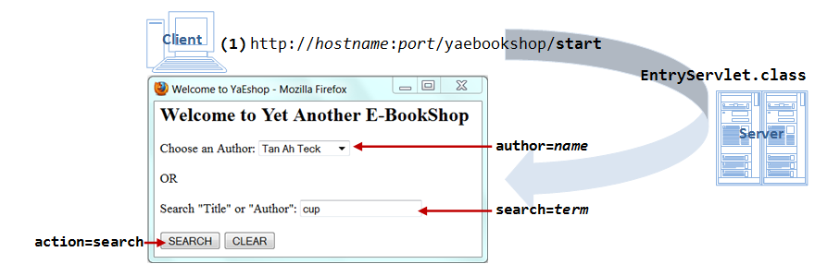

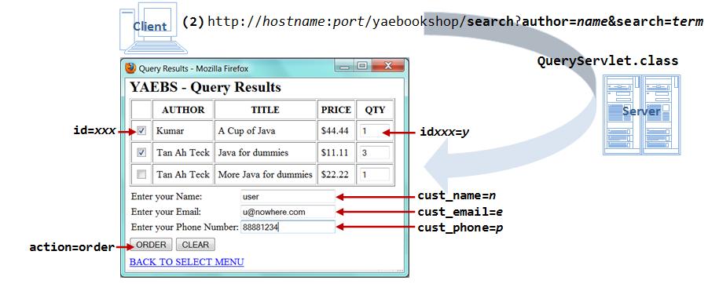

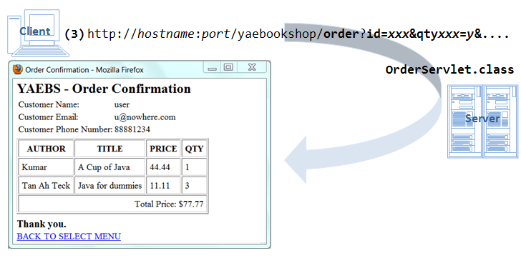

1. Types of Session Tracking in Servlet

There are four main ways to manage the session in java web-application:

* 1. URL rewriting
  2. Cookies
  3. Hidden form fields
  4. HTTPS

Implement the above individually in servlet

1. Create 3 links: login, logout and Register in a web application and from any page if the logout has clicked disable all the session related object and by default hold the session object for max of 15 min in an application.
2. How to Retrieve Data from ServletConfig Interface Object.
3. How to Retrieve Data from ServletContext Interface Object